Amy Wang
MSCI 240 Fall 2018
Instructor: Dr Mark Hancock
September 28th, 2018
Homework 1

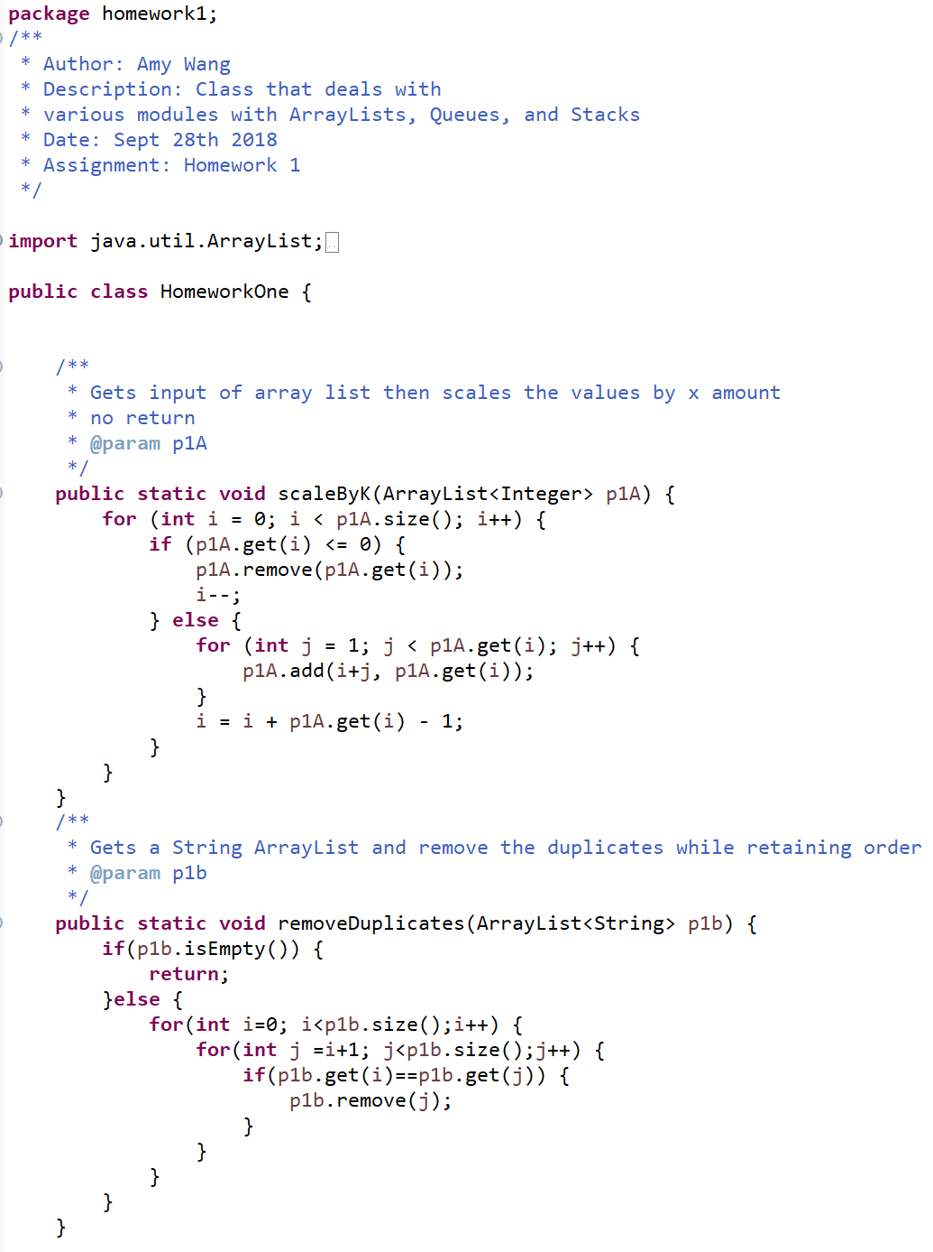

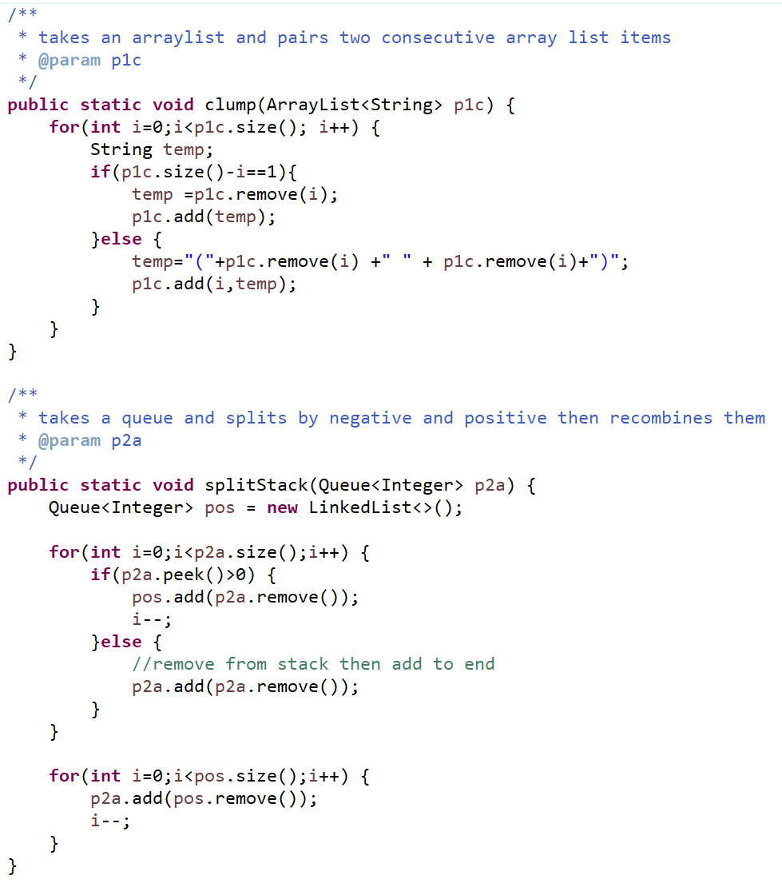

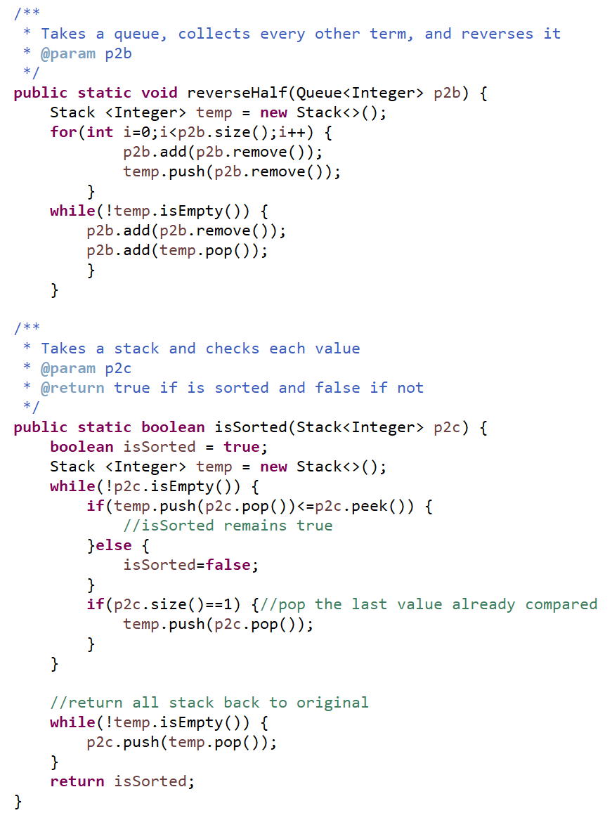Non-Acknowledgment of Receiving Assistance or Use of Others' Ideas
I received the following help, assistance, or any ideas from classmates, other knowledgeable people, books or non-course websites (please include a description of discussions with the TA or the instructor):
None

Record of Giving Assistance to Others
I gave the following help, assistance, or ideas to the following classmates (please describe what assistance to whom was given by you):
None

Declaration
I declare that except for the assistance noted above, assistance provided on the course website, and material provided by the instructor and/or TAs that this is my original work.
I have neither given nor received an electronic or printed version of any part of this code to/from anyone.
I declare that any program output submitted as part of the assignment was generated by the program code submitted and not altered in any way.
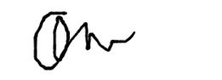
Signature: _______________________________

